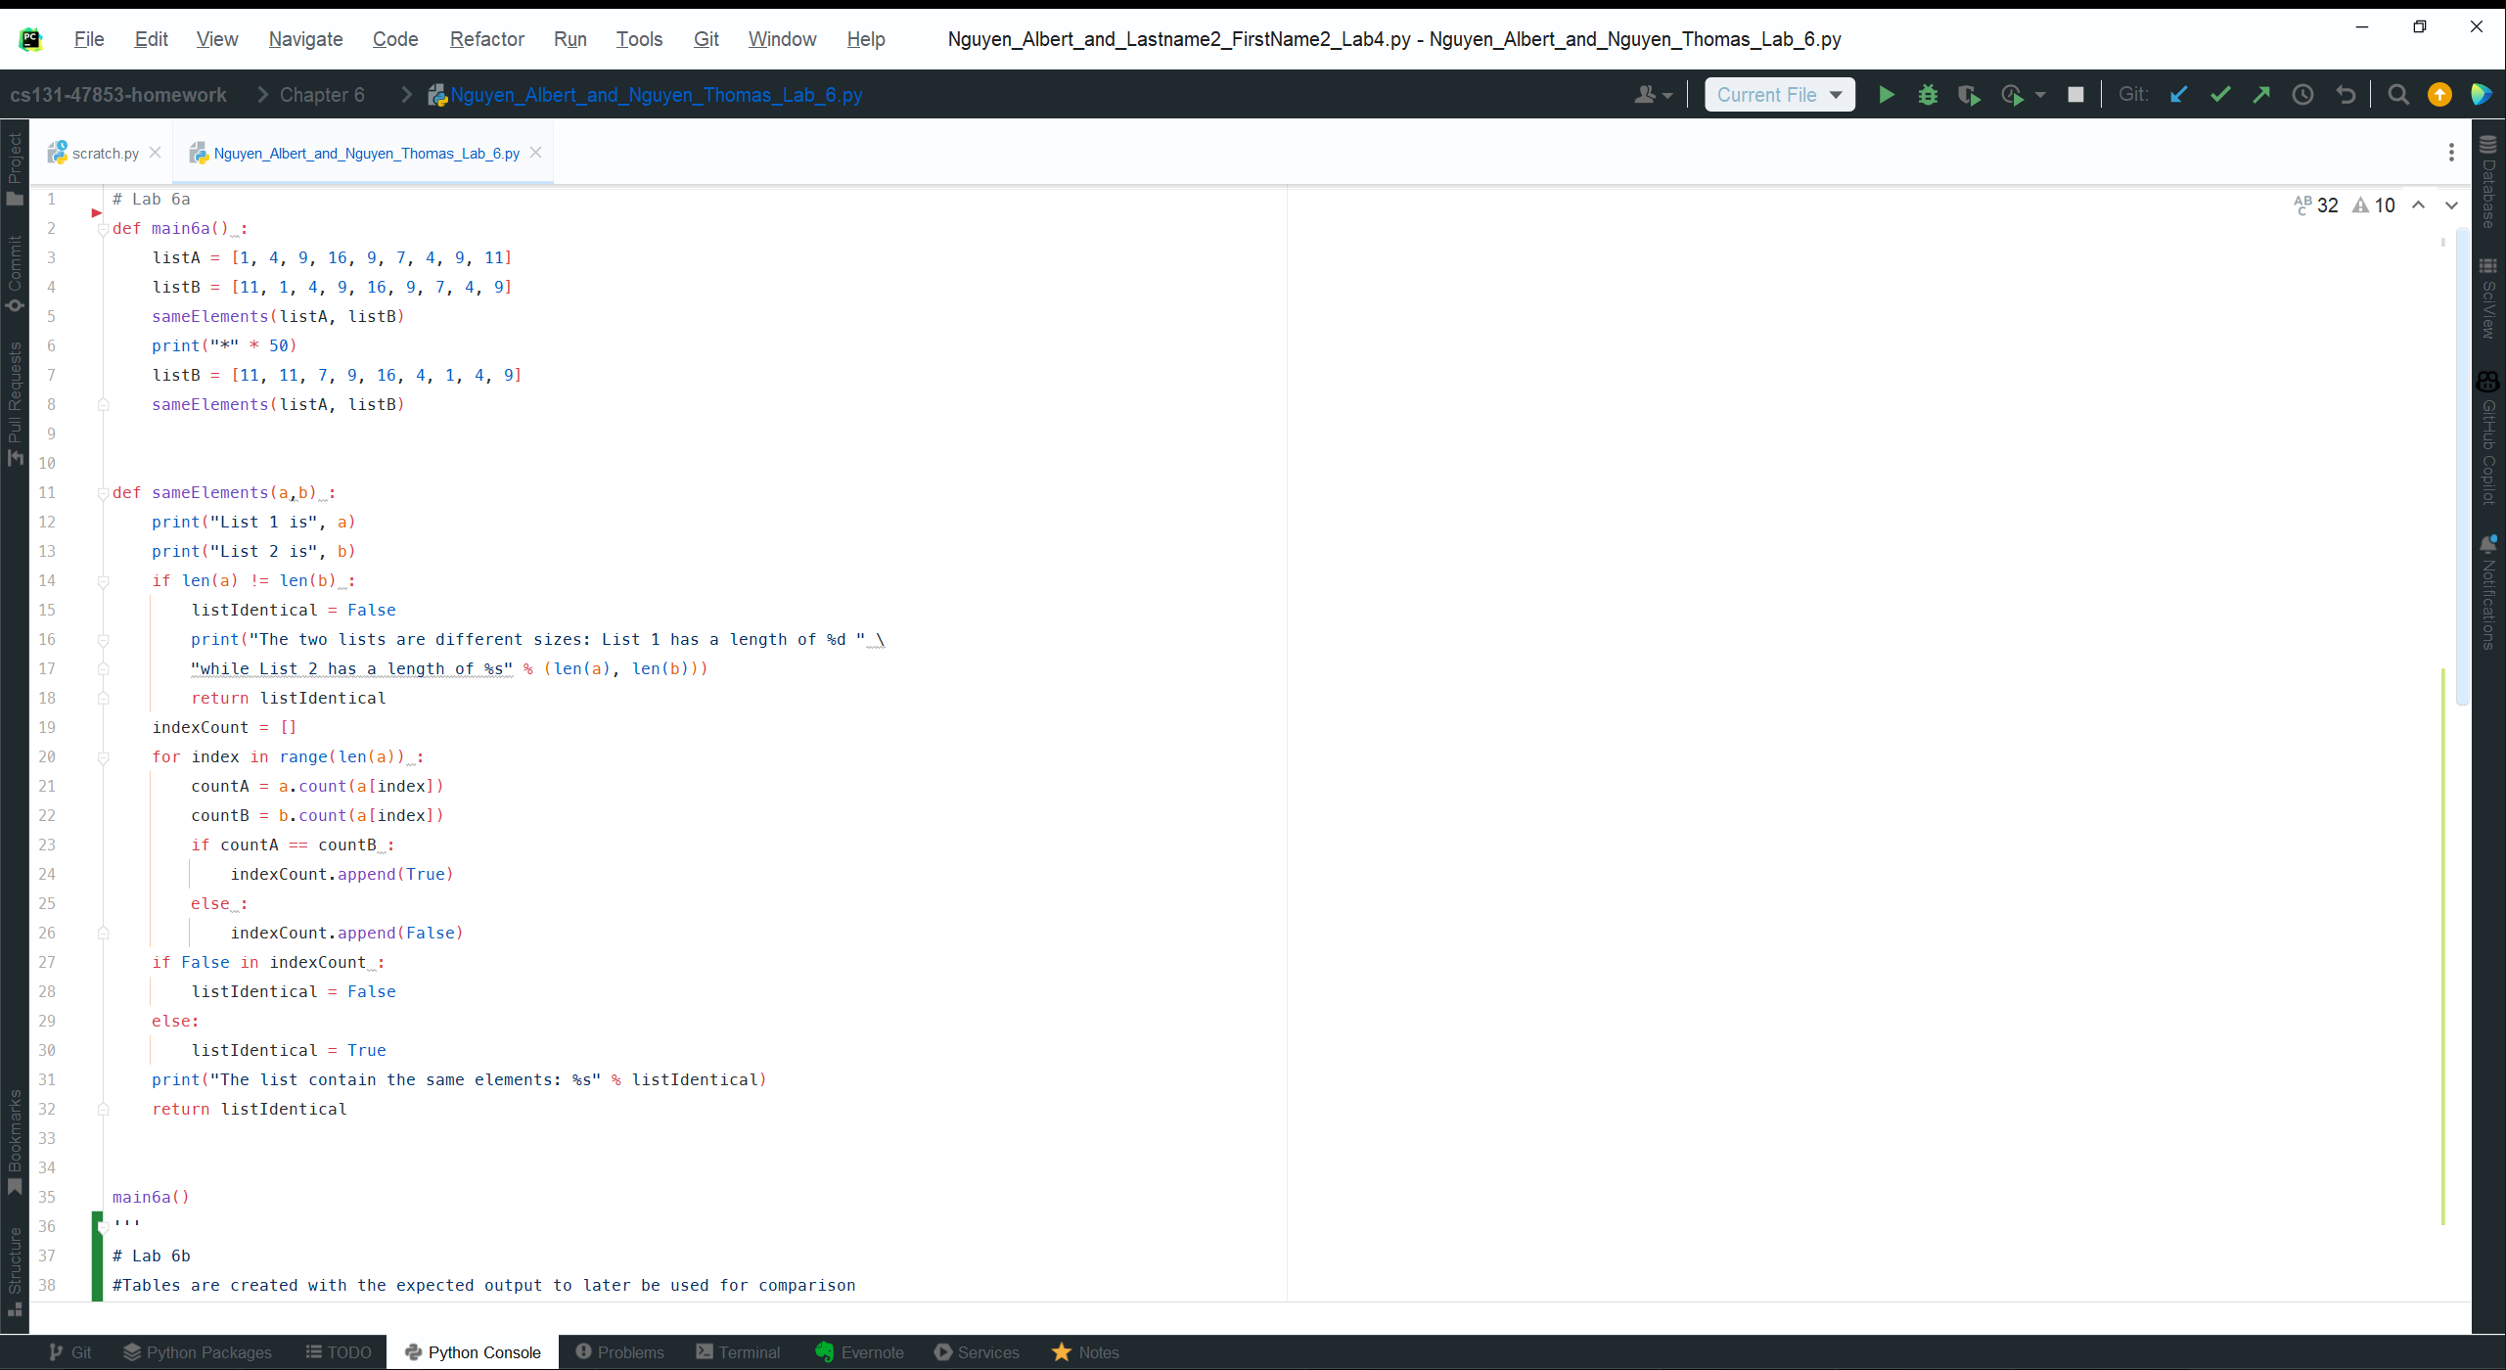

6a_Code

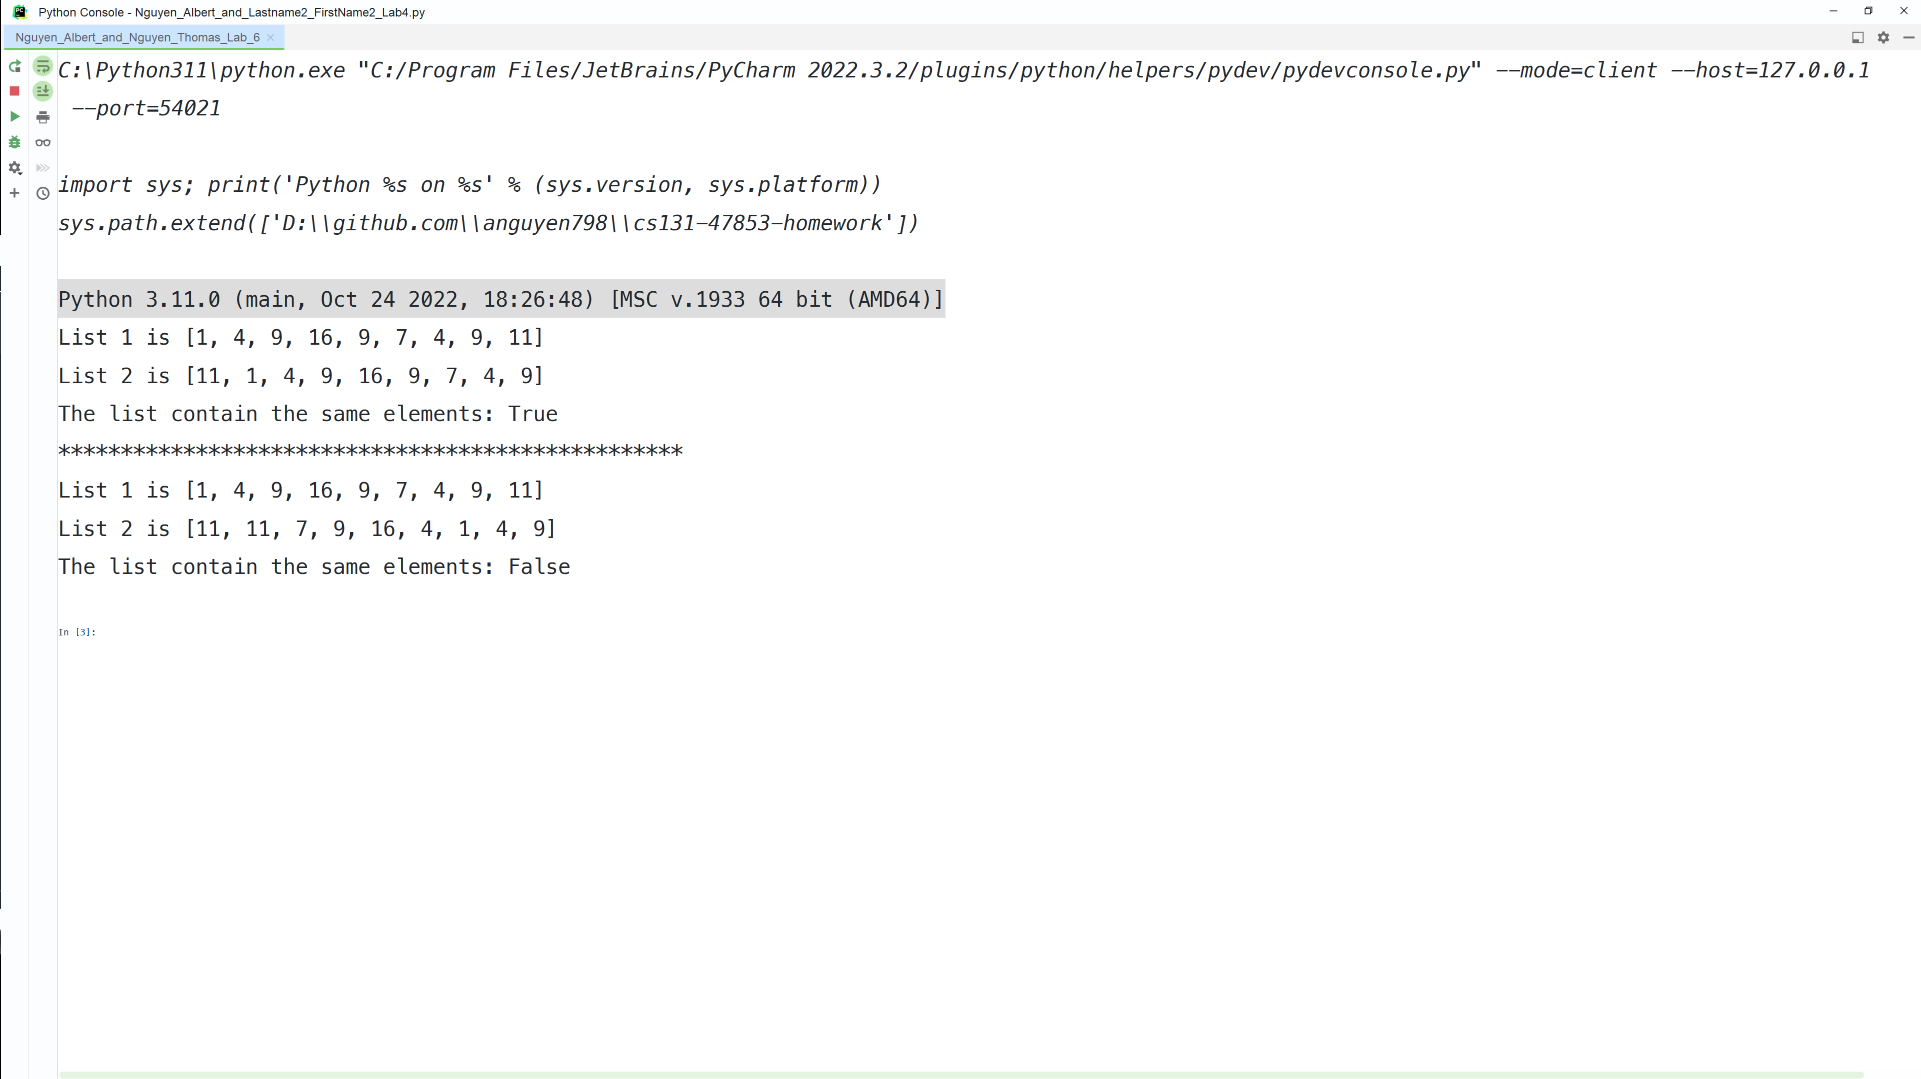

6a_Output

# Lab 6a
def main6a() :
listA = [1, 4, 9, 16, 9, 7, 4, 9, 11]
listB = [11, 1, 4, 9, 16, 9, 7, 4, 9]
sameElements(listA, listB)
print("*" * 50)
listB = [11, 11, 7, 9, 16, 4, 1, 4, 9]
sameElements(listA, listB)
def sameElements(a,b) :
print("List 1 is", a)
print("List 2 is", b)
if len(a) != len(b) :
listIdentical = False
print("The two lists are different sizes: List 1 has a length of %d " \
"while List 2 has a length of %s" % (len(a), len(b)))
return listIdentical
indexCount = []
for index in range(len(a)) :
countA = a.count(a[index])
countB = b.count(a[index])
if countA == countB :
indexCount.append(True)
else :
indexCount.append(False)
if False in indexCount :
listIdentical = False
else:
listIdentical = True
print("The list contain the same elements: %s" % listIdentical)
return listIdentical
main6a()
6a_Actual
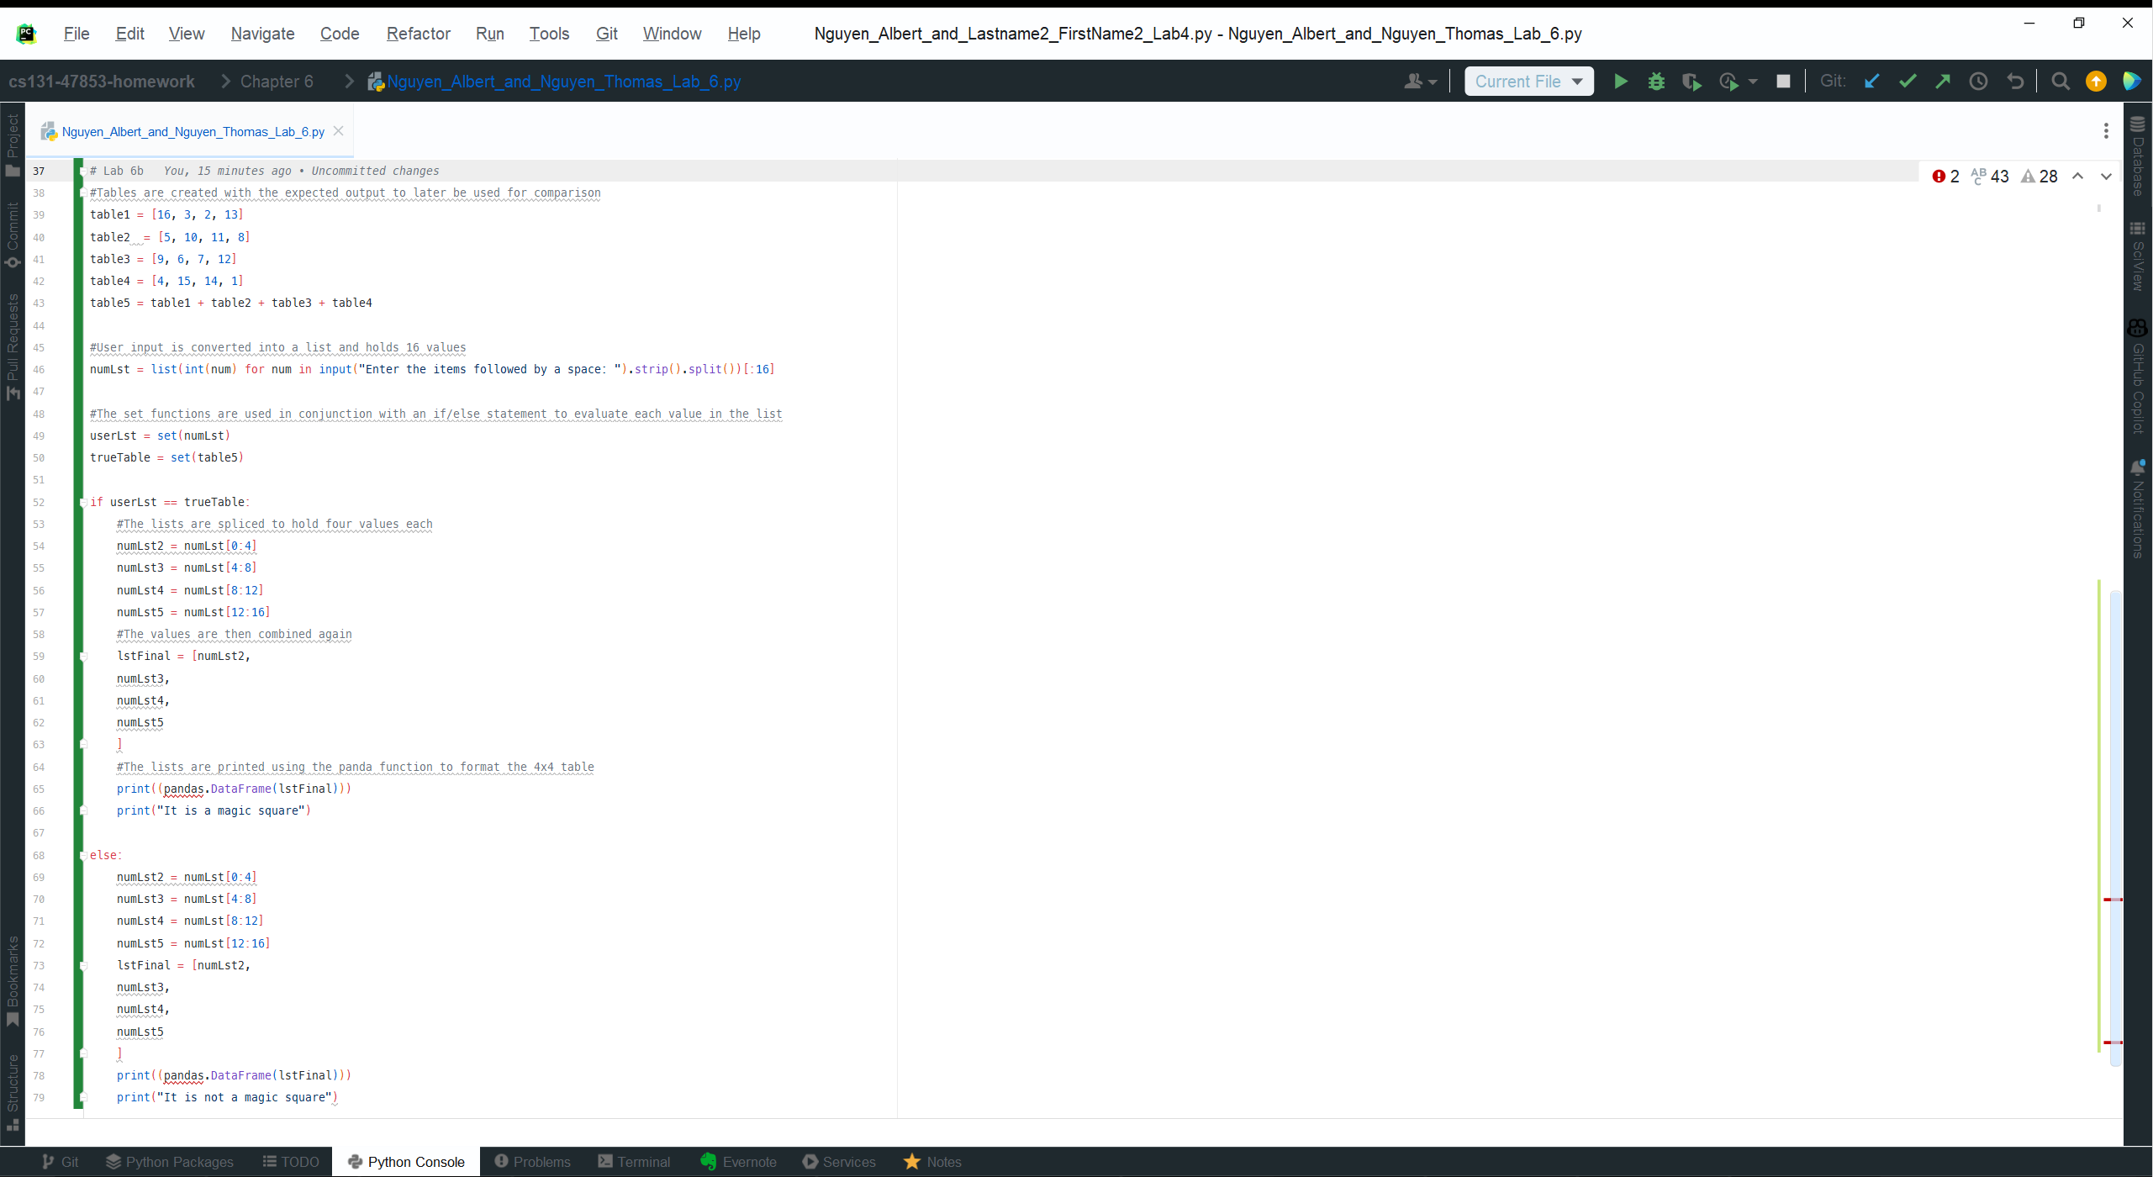

6b_Code

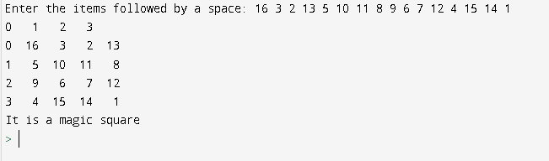

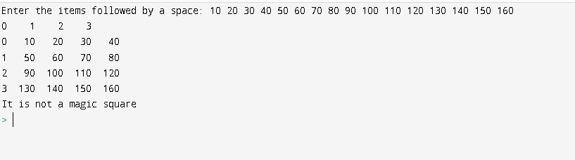

6b_Output

# Lab 6b
import pandas
#Tables are created with the expected output to later be used for comparison
table1 = [16, 3, 2, 13]
table2 = [5, 10, 11, 8]
table3 = [9, 6, 7, 12]
table4 = [4, 15, 14, 1]
table5 = table1 + table2 + table3 + table4
#User input is converted into a list and holds 16 values
numLst = list(int(num) for num in input("Enter the items followed by a space: ").strip().split())[:16]
#The set functions are used in conjunction with an if/else statement to evaluate each value in the list
userLst = set(numLst)
trueTable = set(table5)
if userLst == trueTable:
#The lists are spliced to hold four values each
numLst2 = numLst[0:4]
numLst3 = numLst[4:8]
numLst4 = numLst[8:12]
numLst5 = numLst[12:16]
#The values are then combined again
lstFinal = [numLst2,
numLst3,
numLst4,
numLst5
]
#The lists are printed using the panda function to format the 4x4 table
print((pandas.DataFrame(lstFinal)))
print("It is a magic square")
else:
numLst2 = numLst[0:4]
numLst3 = numLst[4:8]
numLst4 = numLst[8:12]
numLst5 = numLst[12:16]
lstFinal = [numLst2,
numLst3,
numLst4,
numLst5
]
print((pandas.DataFrame(lstFinal)))
print("It is not a magic square")

6b_Actual

6a_Code
6a_Output
6a_Actual
6b_Code - import pandas is at top of python code
6b_Output
6b_Actual

